**INDEX**

|  |  |  |
| --- | --- | --- |
| **Sr.No.** | **PRACTICALS** | **SIGN** |
| 1. | Blinking of LEDs |  |
| 2. | Program using Light Sensitive Sensors. |  |
| 3. | Program using temperature sensors. |  |
| 4. | Program using humidity sensors. |  |
| 5. | Program using Line tracking sensors. |  |
| 6. | Program using Ultrasonic Sensors. |  |
| 7. | Program using digital infrared motion sensors. |  |
| 8. | Program using gas sensors. |  |
| 9. | Program using servo motors. |  |
| 10. | Program making Joystick with Arduino. |  |

**PRACTICAL NO. 1**

**Introduction to Arduino**

**Introduction to Arduino circuits and breadboarding**

**Blinking of LEDs**

**Code:**

int red=12;

void setup()

{

pinMode(red, OUTPUT);

}

void loop()

{

digitalWrite(red, HIGH);

delay(1000);

digitalWrite(red, LOW);

delay(1000);//Delay a little bit to improve simulation performance

}

**Output:**

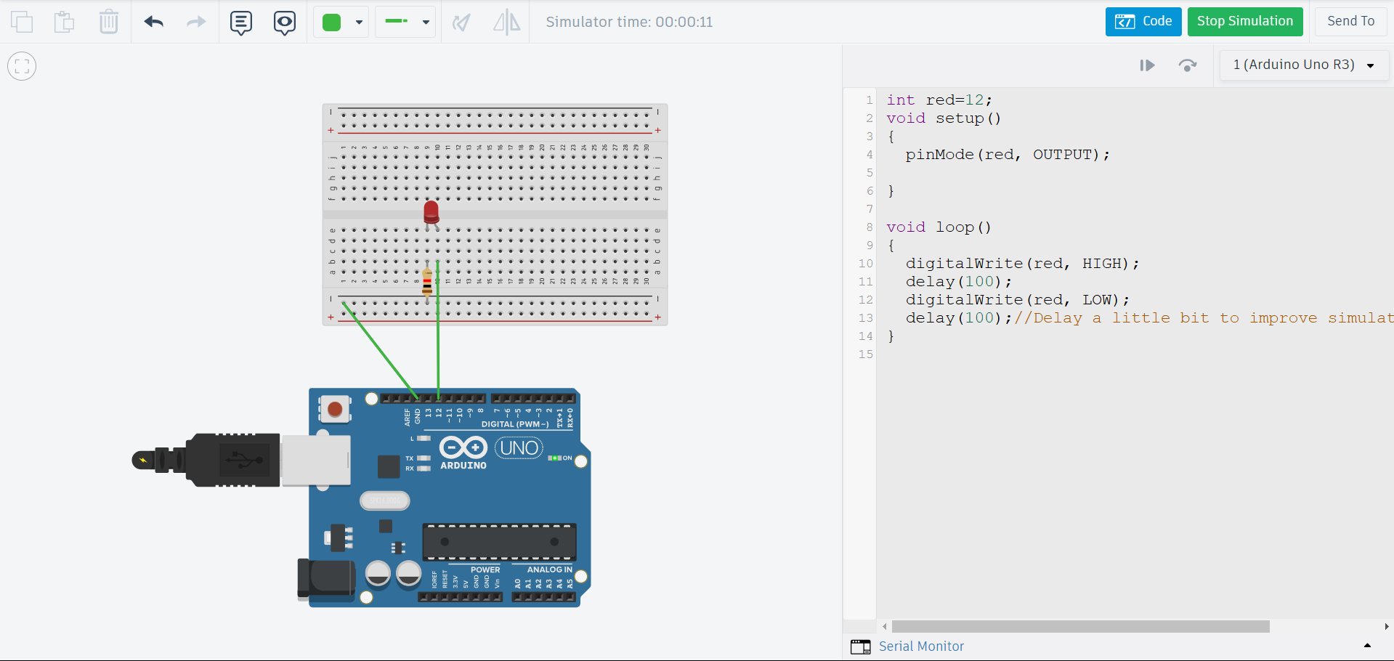

**PRACTICAL NO. 2**

**Program using Light Sensitive Sensors**

**Code:**

int ldrPin = A0;

int ledPin = 9;

int ldrValue;

void setup() {

pinMode(ledPin, OUTPUT);

Serial.begin(9600);

}

void loop() {

ldrValue = analogRead(ldrPin);

Serial.println(ldrValue);

if (ldrValue < 500) {

digitalWrite(ledPin, HIGH);

} else {

digitalWrite(ledPin, LOW);

}

delay(100);

}

**Output:**

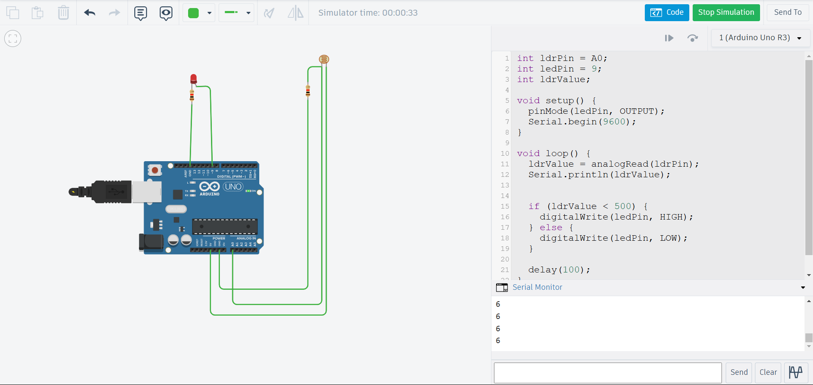

**PRACTICAL NO. 3**

**Program using temperature sensors**

**Code:**

byte tmp = A1;

byte led= 2;

int temp;

void setup()

{

pinMode (tmp, INPUT);

pinMode(2, OUTPUT);

Serial.begin(9600);

}

void loop()

{

temp=analogRead(temp);

temp=temp * 0.488;

Serial.print("temp:");

Serial.println(temp);

if (temp < 50){

digitalWrite(2, HIGH);

}

else {

digitalWrite(2, LOW);

}

delay(1000);

}

**Output:**

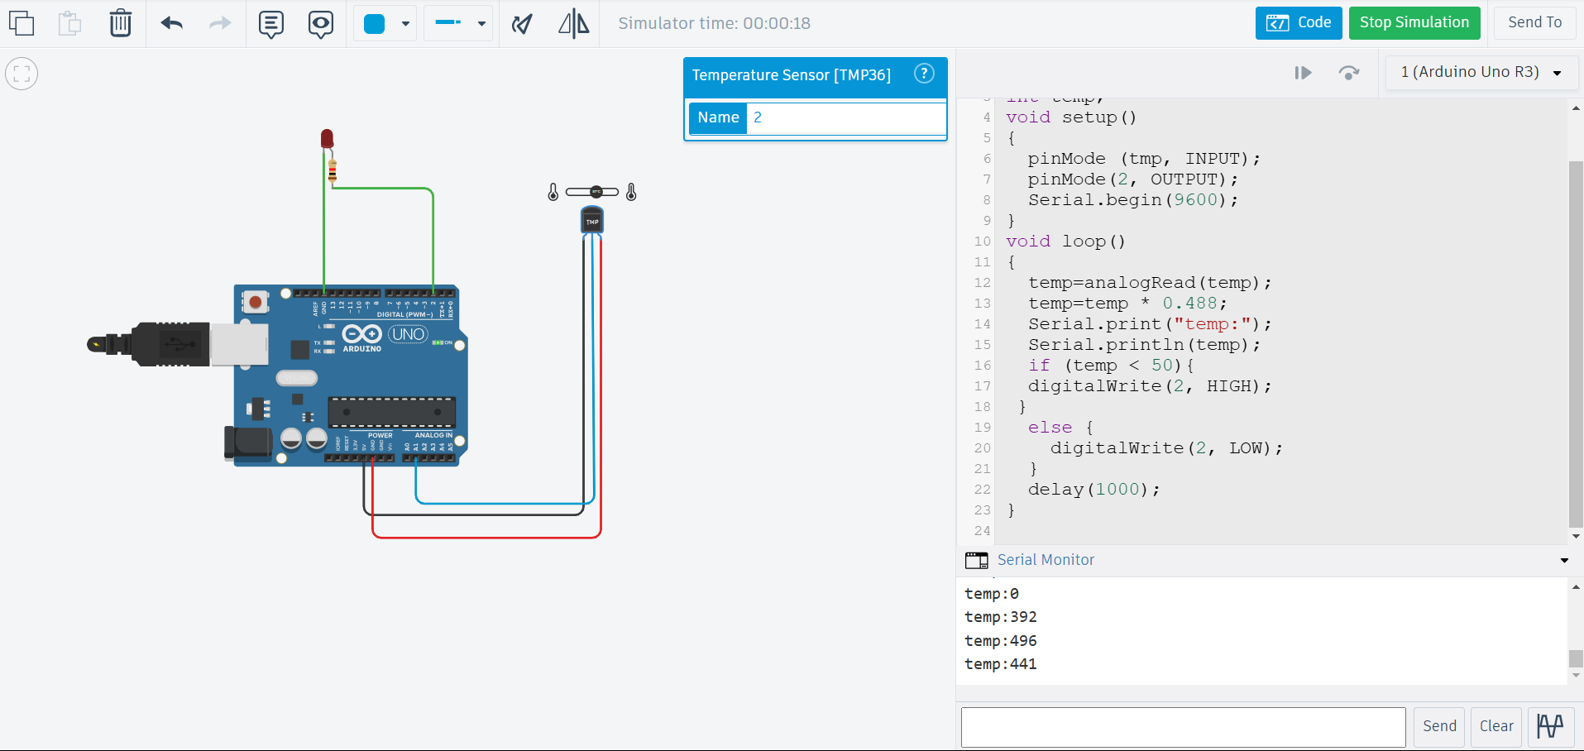

**PRACTICAL NO. 4**

**Program using humidity sensors**

**Code:**

void setup() {

Serial.begin(9600);

Serial.println("Simulated DHT11 Sensor");

}

void loop() {

int sensorValue = analogRead(A0);

float humidity = map(sensorValue, 0, 1023, 20, 90);

Serial.print("Simulated Humidity: ");

Serial.print(humidity);

Serial.println(" % ");

delay(1000);

}

**Output:**

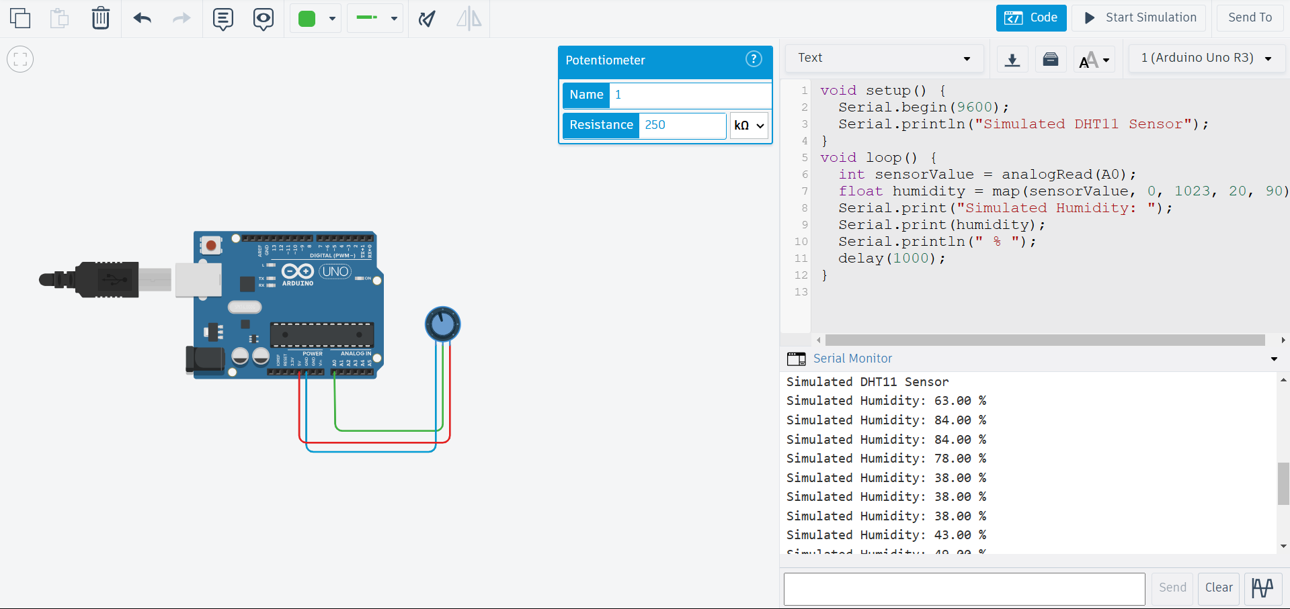

**PRACTICAL NO. 5**

**Programs using Line tracking sensors**

**Code:**

int sensorPin = 2;

int ledPin = 13;

void setup() {

pinMode(sensorPin, INPUT);

pinMode(ledPin, OUTPUT);

Serial.begin(9600);

}

void loop() {

int sensorValue = digitalRead(sensorPin);

if (sensorValue == LOW) {

digitalWrite(ledPin, HIGH);

Serial.println("Line detected!");

} else {

digitalWrite(ledPin, LOW);

Serial.println("No line detected.");

}

delay(1000);

}

**Output:**

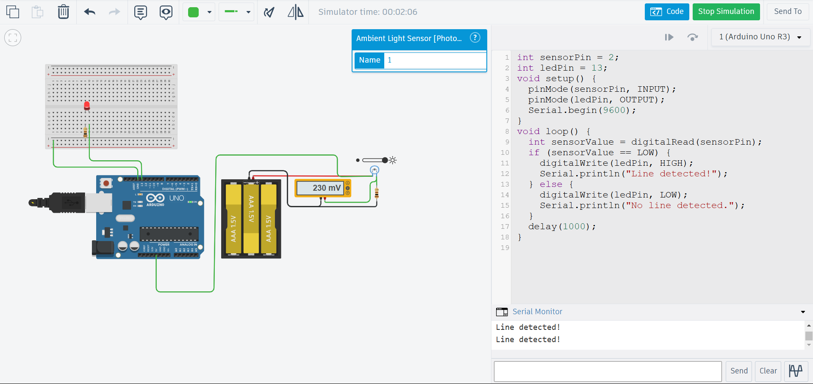

**PRACTICAL NO. 6**

**Programs using Ultrasonic Sensors**

**Code:**

const int trigPin = 9;

const int echoPin = 10;

long duration;

int distance;

void setup() {

Serial.begin(9600);

pinMode (trigPin, OUTPUT);

pinMode (echoPin, INPUT);

}

void loop() {

digitalWrite(trigPin, LOW);

delayMicroseconds (2);

digitalWrite(trigPin, HIGH);

delayMicroseconds(10);

digitalWrite(trigPin, LOW);

duration= pulseIn (echoPin, HIGH);

distance = duration * 0.34 / 2;

Serial.print("Distance: ");

Serial.print(distance);

Serial.println("cm");

delay(2000); //Delay for readability

}

**Output:**

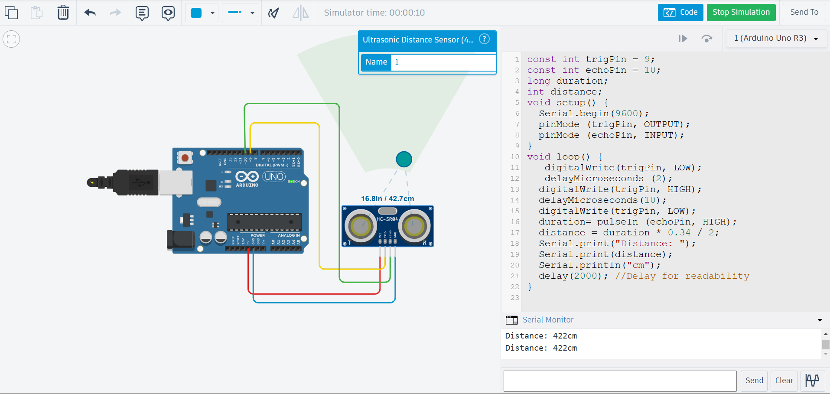

**PRACTICAL NO. 7**

**Programs using digital infrared motion sensors**

**Code:**

const int PIR_PIN = 2;

const int LED_PIN = 13;

void setup() {

pinMode(PIR_PIN, INPUT);

pinMode(LED_PIN, OUTPUT);

Serial.begin(9600);

}

void loop() {

int motionState = digitalRead(PIR_PIN);

if (motionState == HIGH) {

digitalWrite(LED_PIN, HIGH);

Serial.println("Motion Detected!");

} else {

digitalWrite(LED_PIN, LOW);

Serial.println("No Motion");

}

delay(500);

}

**Output:**

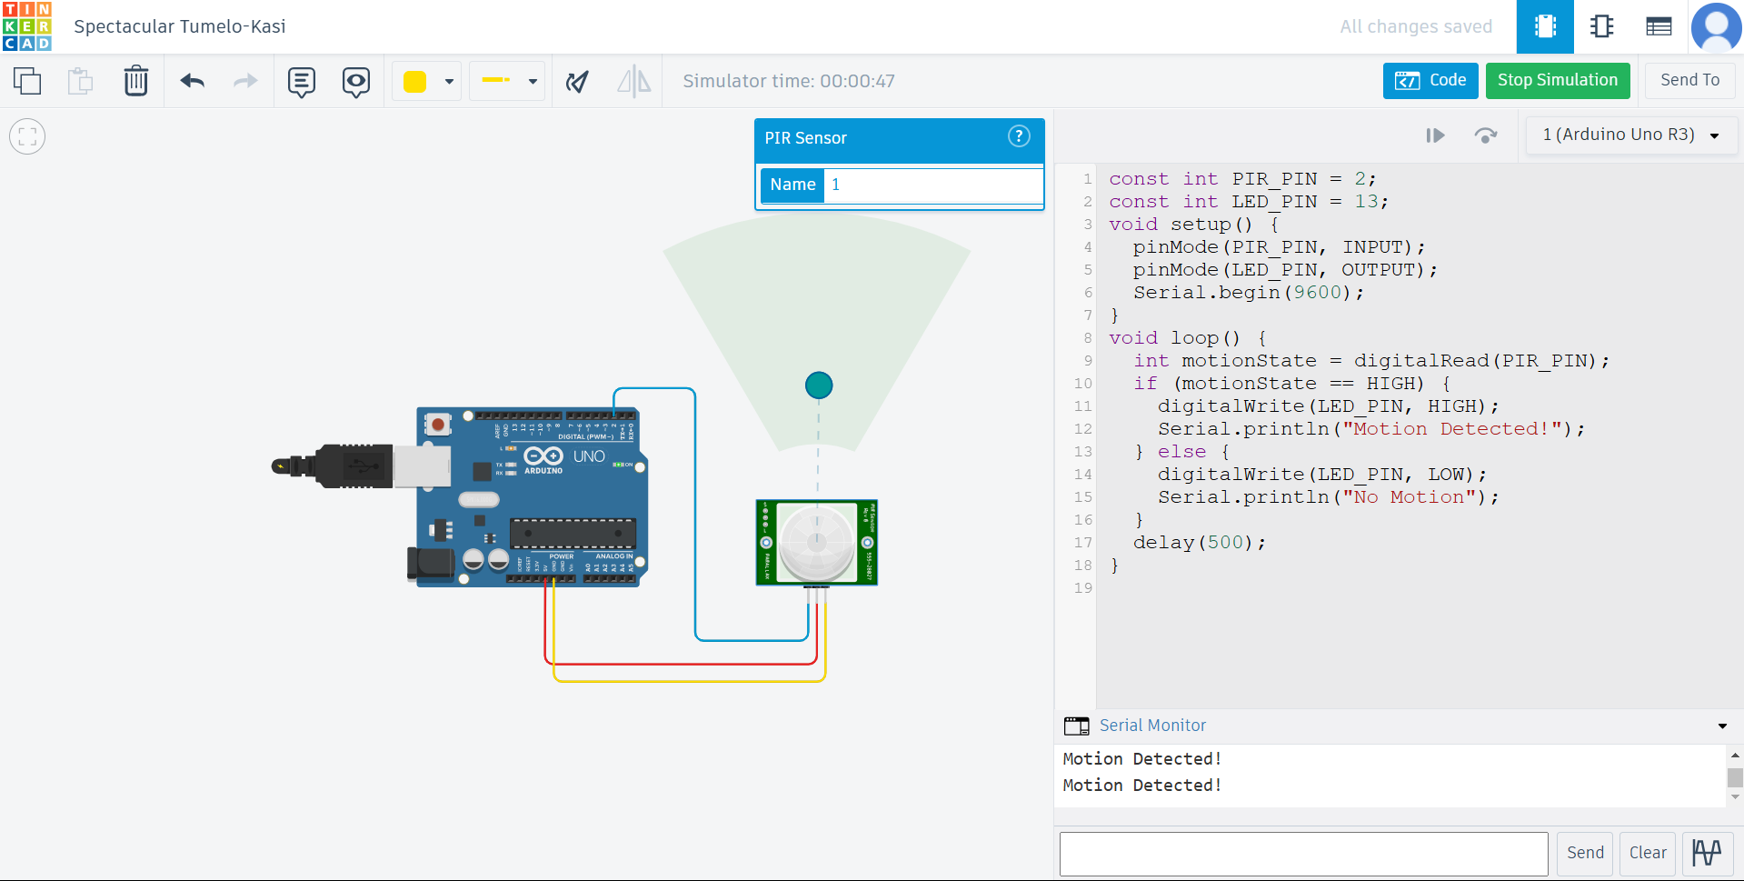

**PRACTICAL NO. 8**

**Programs using gas sensors**

**Code:**

int LED = 13;

int MQ2pin = A0;

void setup()

{

Serial.begin(9600);

}

void loop()

{

float sensorValue;

sensorValue = analogRead(MQ2pin);

if(sensorValue >= 250)

{

digitalWrite(LED, HIGH);

Serial.print(sensorValue);

Serial.println(" | GAS DETECTED");

}

else

{

digitalWrite(LED, LOW);

Serial.println("Sensor Value: ");

Serial.println(sensorValue);

}

delay(1000);

}

**Output:**

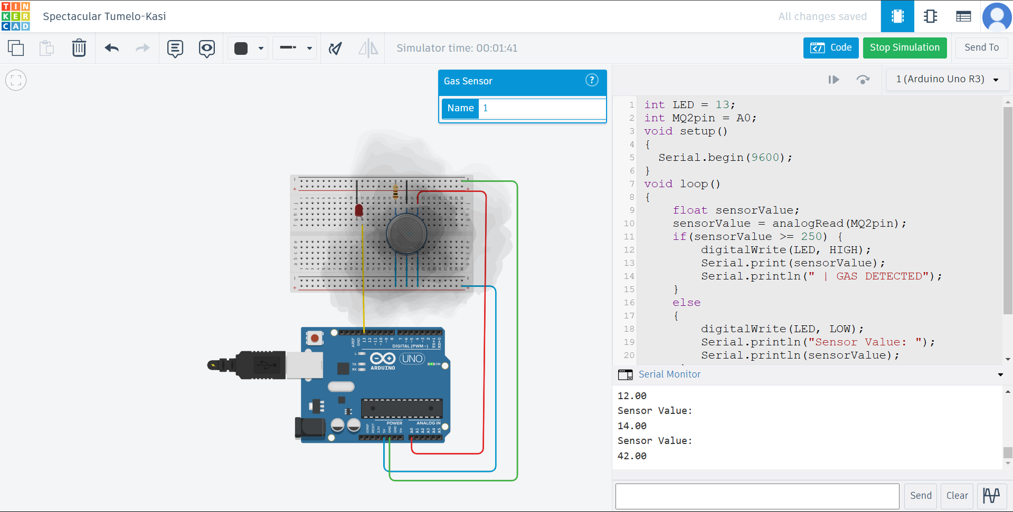

**PRACTICAL NO. 9**

**Programs using servo motors**

**Code:**

#include<Servo.h>

Servo servo1;

int pos = 0;

void setup()

{

servo1.attach(13);

}

void loop()

{

for(pos=0;pos<=180;pos++)

{

servo1.write(pos);

delay(15);

}

for(pos=180;pos>=0;pos--)

{

servo1.write(pos);

delay(15);

}

}

**Output:**

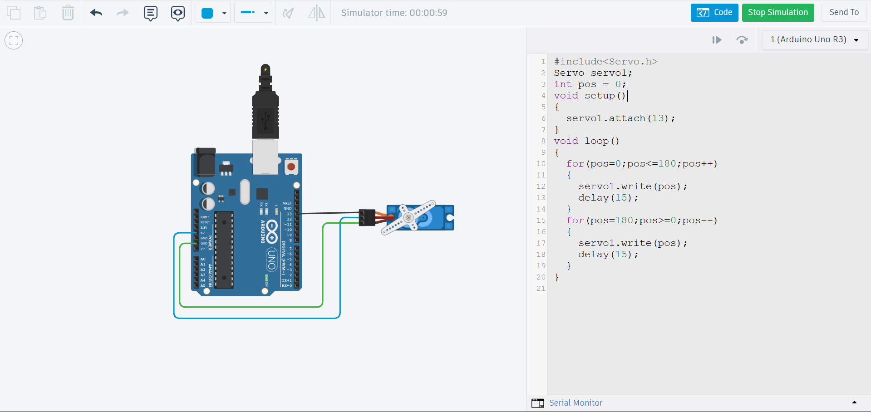

**PRACTICAL NO. 10**

**Programs making Joystick with Arduino**

**Code:**

int x[50] = {0};

int y[50] = {0};

int LED_UP = 2;

int LED_DOWN = 3;

int LED_RIGHT = 4;

int LED_LEFT = 5;

void setup() {

Serial.begin(9600);

pinMode(LED_UP, OUTPUT);

pinMode(LED_DOWN, OUTPUT);

pinMode(LED_RIGHT, OUTPUT);

pinMode(LED_LEFT, OUTPUT);

}

void loop() {

long int sumX = 0;

long int sumY = 0;

for (int i = 0; i < 50; i++) {

x[i] = analogRead(A0);

sumX += x[i];

y[i] = analogRead(A1);

sumY += y[i];

}

int Xm = sumX / 50;

int Ym = sumY / 50;

int up = 0;

int down = 0;

int right = 0;

int left = 0;

if (Xm <= 500) {

up = map(Xm, 500, 0, 0, 100);

}

if (Xm >= 500) {

down = map(Xm, 500, 1021, 0, 100);

}

if (Ym <= 506) {

right = map(Ym, 506, 0, 0, 100);

}

if (Ym >= 506) {

left = map(Ym, 506, 1021, 0, 100);

}

digitalWrite(LED_UP, LOW);

digitalWrite(LED_DOWN, LOW);

digitalWrite(LED_RIGHT, LOW);

digitalWrite(LED_LEFT, LOW);

if (up > down) {

digitalWrite(LED_UP, HIGH);

} else if (down > up) {

digitalWrite(LED_DOWN, HIGH);

}

if (right > left) {

digitalWrite(LED_RIGHT, HIGH);

} else if (left > right) {

digitalWrite(LED_LEFT, HIGH);

}

String phrase1 = "Xm = " + String(Xm) + " - Ym = " + String(Ym);

String phrase2 = "UP: " + String(up) + " - DOWN: " + String(down) + " - RIGHT: " + String(right) + " - LEFT: " + String(left);

Serial.println(phrase1);

Serial.println(phrase2);

delay(1000);

}

**Output:**

